**Task 4-GPT**

**Common CSS Issues and How to Debug Them**

CSS issues can arise from various factors, including specificity conflicts, improper selectors, and layout problems. Here’s a guide on how to debug CSS issues using browser developer tools.

**Common CSS Issues**

1. **Specificity Conflicts**:
   * When multiple CSS rules apply to the same element, the browser uses specificity to determine which rule to apply.
2. **Incorrect Selectors**:
   * Using the wrong selector (e.g., targeting a class instead of an ID) can prevent styles from being applied.
3. **Box Model Issues**:
   * Misunderstanding the box model can lead to unexpected layout problems, such as elements overlapping or being misaligned.
4. **Inheritance Issues**:
   * Styles may not apply as expected due to inheritance. Child elements may inherit unwanted styles from parent elements.
5. **Browser Compatibility**:
   * Some CSS properties may not work in all browsers, leading to inconsistent appearances.

**Step-by-Step Guide to Debug CSS Using Browser Developer Tools**

1. **Open Developer Tools**:
   * Right-click on the webpage and select "Inspect" or press F12 (Windows) / Cmd + Option + I (Mac) to open developer tools.
2. **Inspect Elements**:
   * Use the **Elements** tab to hover over and click on the element you want to inspect. This will show the HTML structure and applied styles.
3. **Check Applied Styles**:
   * In the right panel, you'll see the **Styles** pane. This lists all CSS rules applied to the selected element. Look for crossed-out styles to identify overrides.
4. **Modify CSS Live**:
   * You can click on any style property to edit it directly. Change values or add new properties to see how they affect the element live.
5. **Check Computed Styles**:
   * Switch to the **Computed** tab to see all final styles applied to the element, including those inherited from parent elements.
6. **Use the Console**:
   * If you need to run JavaScript commands or check for errors, switch to the **Console** tab for debugging.

**Real Example of a CSS Issue and Resolution**

**Example Issue**: A button that is supposed to be centered on the page is not aligning correctly.

**HTML**:

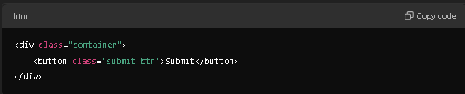

**CSS:**

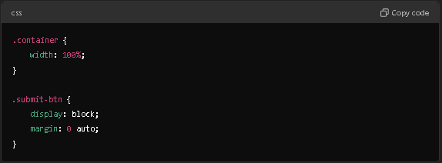

**Issue**: The button does not center as expected.

**Debugging Steps**:

1. **Inspect the Button**: Open developer tools and click on the button.
2. **Check Styles**: Look at the **Styles** pane. Notice if there are any other styles affecting the button's layout.
3. **Modify CSS**:
   * Check if the margin: 0 auto; is applied correctly. If the button's width is not specified, it will not center. Adjust the CSS:

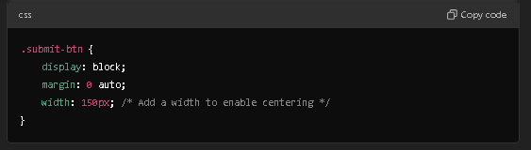

1. **Check Computed Styles**: Look at the **Computed** tab to see if any conflicting styles are affecting the button's position.
2. **Test Changes Live**: Make the CSS changes directly in the developer tools to see the effect immediately. Once satisfied, update the actual CSS file.

### Conclusion

Using browser developer tools is an effective way to debug CSS issues. By inspecting elements, checking applied styles, and modifying CSS live, you can quickly identify and resolve common problems. With practice, these debugging techniques will help streamline your development process and improve your CSS skills.